Megan Leonard

5/23/2021

# COMP 201 Homework 1

Answer the following questions based on your reading of the text book, the module study notes, the videos, and the instructor’s presentation this week.

1. (Englander, exercise 2.5, page 68) Figure 2.8 illustrates the basic architecture for a three-tier database system. This system can be viewed as an IPO system. What is the input for this system? What environmental element generates the input? (Hint: the Web browser computer is within the system boundary.) What is the expected output from this system? What environmental element receives the output? Briefly describe the processing that takes place in this system.

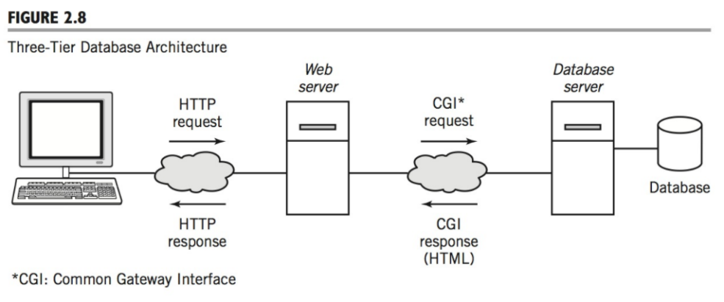

The input for this system starts with the user input to the computer. The computer takes the input and send it to the web server. In the figure the input is shown as the HTTP request that comes from the computer and is sent to the web server. The environmental element that generates the input is the web server as it takes the HTTP request and sends a CGI request to the database server. The database server sends the output of the CGI response to the web server. The web server then acts as the environmental element to receive the output and change it into an HTTP response. Finally, it will send to HTTP response back to the computer where the input originally came from.

1. (Englander, exercise 2.8, page 68) Suppose that you have been hired to develop a website-based sales system for a large international retail sales firm. Discuss some environmental issues that are specific to the Web design of your system that you must consider if your system is to be successful at attracting and keeping purchasing customers.

The specific environmental issues that come with the web design of the system would be based around the customers and who they are as people. The sales system is for a large international retail sails firm which means that it will reach out to several different countries. That being said, each country has its own rules when it comes to sales and selling to the people of that country. There are also the differences in languages and cultures that would cause issues with the design. For example, in the US the majority of citizens speak English while in another place like Mexico, the primary language is Spanish. The differences in culture also change the appeal of the design for each person. A person in Japan and one in Russia may not have the same design preference and could have clashing opinions. To keep and attract purchasing customers the design would have to appeal to at least some people which means the company would need to decide who they are aiming to sell to based off of what they are selling and who that would appeal to before the design can be made to match the desire of the customers.

1. (Englander, exercise 3.2, page 96) Determine the power of each digit for four-digit numbers in base 16. Which place digits in base 2 have the same power?

For the four digits in the number at base 16 we would have: a*163+b*162+c*161+d*160 that would lead to the powers being 4096, 256, 16 and 1.

To get the same power for base 2 we would have 4096 at 12th , at 256 is would be 8th , 16 would be 4th, and then 1 at 0th.

1. (Englander, exercise 3.7, page 96) Using hexadecimal:
   1. Create the hexadecimal multiplication table.

|  |  |  |  |  |  |  |  |  |  |  |  |  |  |  |  |  |
| --- | --- | --- | --- | --- | --- | --- | --- | --- | --- | --- | --- | --- | --- | --- | --- | --- |
| + | 0 | 1 | 2 | 3 | 4 | 5 | 6 | 7 | 8 | 9 | A | B | C | D | E | F |
| 0 | 0 | 0 | 0 | 0 | 0 | 0 | 0 | 0 | 0 | 0 | 0 | 0 | 0 | 0 | 0 | 0 |
| 1 | 0 | 1 | 2 | 3 | 4 | 5 | 6 | 7 | 8 | 9 | A | B | C | D | E | F |
| 2 | 0 | 2 | 4 | 6 | 8 | A | C | E | 10 | 12 | 14 | 16 | 18 | 1A | 1C | 1E |
| 3 | 0 | 3 | 6 | 9 | C | F | 12 | 15 | 18 | 1B | 1E | 21 | 24 | 27 | 2A | 2D |
| 4 | 0 | 4 | 8 | C | 10 | 14 | 18 | 1C | 20 | 24 | 28 | 2C | 30 | 34 | 38 | 3C |
| 5 | 0 | 5 | A | F | 14 | 19 | 1E | 23 | 28 | 2D | 32 | 37 | 3C | 41 | 46 | 4B |
| 6 | 0 | 6 | C | 12 | 18 | 1E | 24 | 2A | 30 | 36 | 3C | 42 | 48 | 4E | 54 | 5A |
| 7 | 0 | 7 | E | 15 | 1C | 23 | 2A | 31 | 38 | 3F | 46 | 4D | 54 | 5B | 62 | 69 |
| 8 | 0 | 8 | 10 | 18 | 20 | 28 | 30 | 38 | 40 | 48 | 50 | 58 | 60 | 68 | 70 | 78 |
| 9 | 0 | 9 | 12 | 1B | 24 | 2D | 36 | 3F | 48 | 51 | 5A | 63 | 6C | 75 | 7E | 87 |
| A | 0 | A | 14 | 1E | 28 | 32 | 3C | 46 | 50 | 5A | 64 | 6E | 78 | 82 | 8C | 96 |
| B | 0 | B | 16 | 21 | 2C | 37 | 42 | 4D | 58 | 63 | 6E | 79 | 84 | 8F | 9A | A5 |
| C | 0 | C | 18 | 24 | 30 | 3C | 48 | 54 | 60 | 6C | 78 | 84 | 90 | 9C | A8 | B4 |
| D | 0 | D | 1A | 27 | 34 | 41 | 4E | 5B | 68 | 75 | 82 | 8F | 9C | A9 | B6 | C3 |
| E | 0 | E | 1C | 2A | 38 | 46 | 54 | 62 | 70 | 7E | 8C | 9A | A8 | B6 | C4 | D2 |
| F | 0 | F | 1E | 2D | 3C | 4B | 5A | 69 | 78 | 87 | 96 | A5 | B4 | C3 | D2 | E1 |

* 1. Use the hexadecimal table in Figure 3.8 to perform the following addition (show your work):

|  |
| --- |
| 2AB3 |
| + 35DC |
| 608F |

To get this we start with 3 + C which is 3 + 12 = 15 which is F. Then B +D is 11 +13 = 24 which is 18 as 1 stands for 16 and 8 is the remainder so carry the 1 so 1+ A+ 5 is 16 making it 0 carry the 1. 2+3+1 is then 6 making the answer 608F

* 1. Add the following numbers (show your work or explain):

|  |
| --- |
| 1FF9 |
| + F7 |
| 20F0 |

This one is 9+7 = 16 so carry 1, F+F+1 = 16 + F so F carry 1, then 1+F = 16, carry the 1 so 1+1 is then 2 making the answer 20F0.

* 1. Multiply the following numbers (show your work or explain):

|  |
| --- |
| 2E26 |
| × 4A |
| D56FC |

Separate the 4 and A and use the table to get the A*6,A*2,A*E, and A*2 to get 1CD7C. Then do the same with the 4 to get B898 adding the two together gets D56FC.

1. (Englander, exercise 3.8, page 97) Add the following binary numbers:

|  |
| --- |
| 101101101 |
| + 10011011 |
|  |

|  |
| --- |
| 110111111 |
| + 110111111 |
|  |

|  |
| --- |
| 11010011 |
| + 10001010 |
|  |

|  |
| --- |
| 1101 |
| 1010 |
| 111 |
| + 101 |
|  |

* 1. Repeat the previous additions by converting each number to hexadecimal, adding, and then converting the result back to binary.

1. (Englander, exercise 3.9, page 97) Multiply the following binary numbers together

|  |
| --- |
| 1101 |
| × 101 |
| 1000001 |

|  |
| --- |
| 11011 |
| × 1011 |
| 100101001 |

1. (Englander, exercise 3.10, page 97) Perform the following binary divisions:
   1.  = 01101100 remainder 1
   2. = 0101000101 remainder 01001
2. (Englander, exercise 3.25, page 99) Convert the following numbers from decimal to hexadecimal. If the answer is irrational, stop at four hexadecimal digits:
   1. 0.6640625 = .AA
   2. 0.3333 = .D05
   3. 69/256 = .19B45A5
3. (Englander, exercise 3.27, page 99) Convert the following numbers from decimal to binary and then to hexadecimal:
   1. 27.625 = 11011.101 = 1B.A
   2. 4192.37761 = 1000001100000.0110000010 = 1060.608
   3. 0.6640625 = 0.1010101 = 0.AA
4. In two to three paragraphs of prose (i.e. sentences, not bullet lists, and 350+ words) using APA style citations if needed, summarize, and interact with the content that was covered this week in class. In your summary, you should highlight the major topics, theories, practices, and knowledge that were covered. Your summary should also interact with the material through personal observations, reflections, and applications to the field of study. In particular, highlight what surprised, enlightened, or otherwise engaged you. Make sure to include at least one thing that you’re still confused about. In other words, you should think and write critically not just about what was presented but also what you have learned through the session. Feel free to ask questions in this as well since it will be returned to you with answers.

This week we started by learning about computer systems and number systems. I have touched on computer systems a bit in my previous cyber security course here at Franklin. The points covered in the first two chapters lined up with some of the previous information I was given. The number systems were also touched on in that same course so it was not too startling to see. The language on some of the problems tripped me up when I started but I was able to figure out mostly what the homework questions have been asking and what was needed.